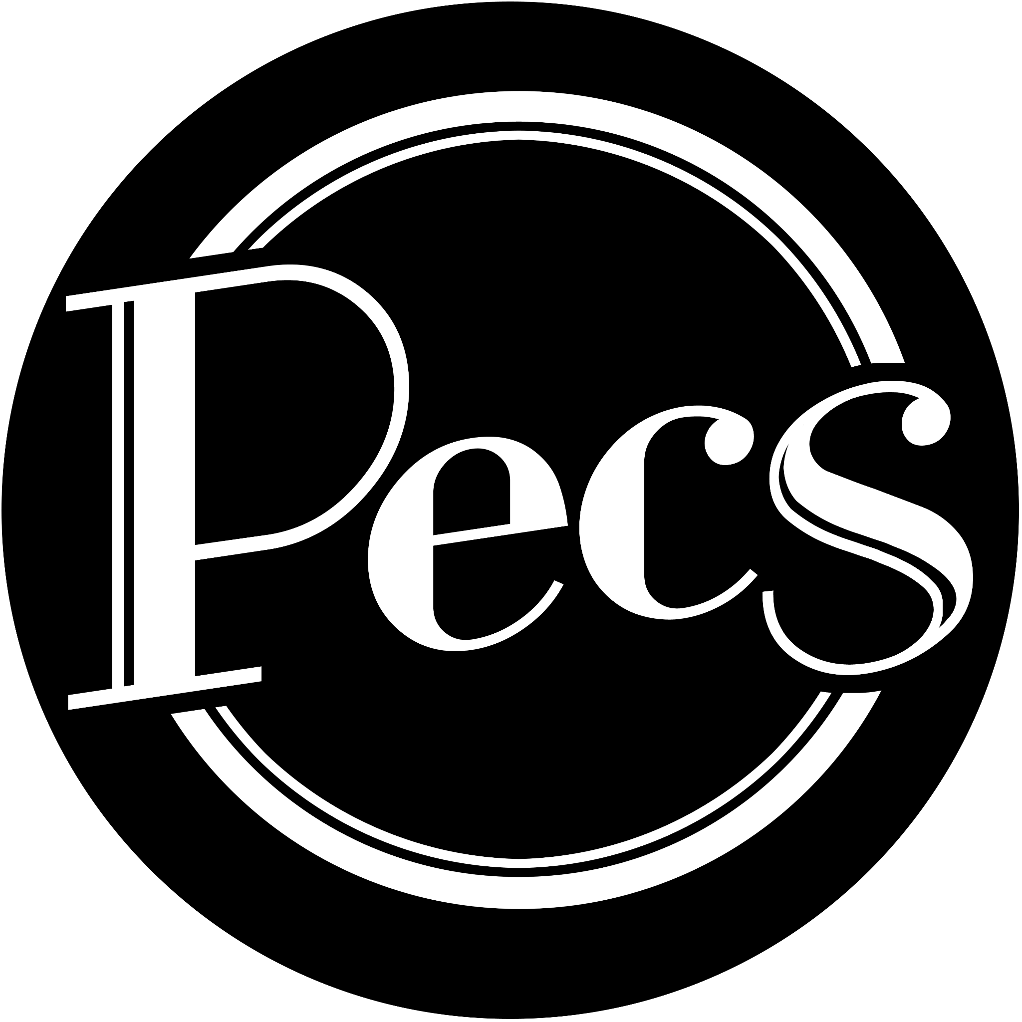

About Pecs Drag Kings

Pecs Drag Kings is an all-women and non-binary theatre and cabaret company which has been creating critically acclaimed shows for the LGBTQ+ community since 2013. Through our drag king cabaret, club nights, podcast, workshops and theatre shows, we explore gender identities, politics and sexuality to create cultural space for queer women, trans* & non-binary folk. Our shows are sexy, raucous and highly entertaining, using songs, dance and comedy to celebrate inclusivity, queerness & community. We run workshops for our community for those wishing to explore their gender and sexuality and step into the shoes of their inner king. Pecs have performed to sold-out audiences at theatres, galleries, pride events & festivals across the UK, and continue to strive to represent Drag Kings and the talented Drag King community wherever we go.

Highlights of our work is below but for more please see www.pecsdragkings.com

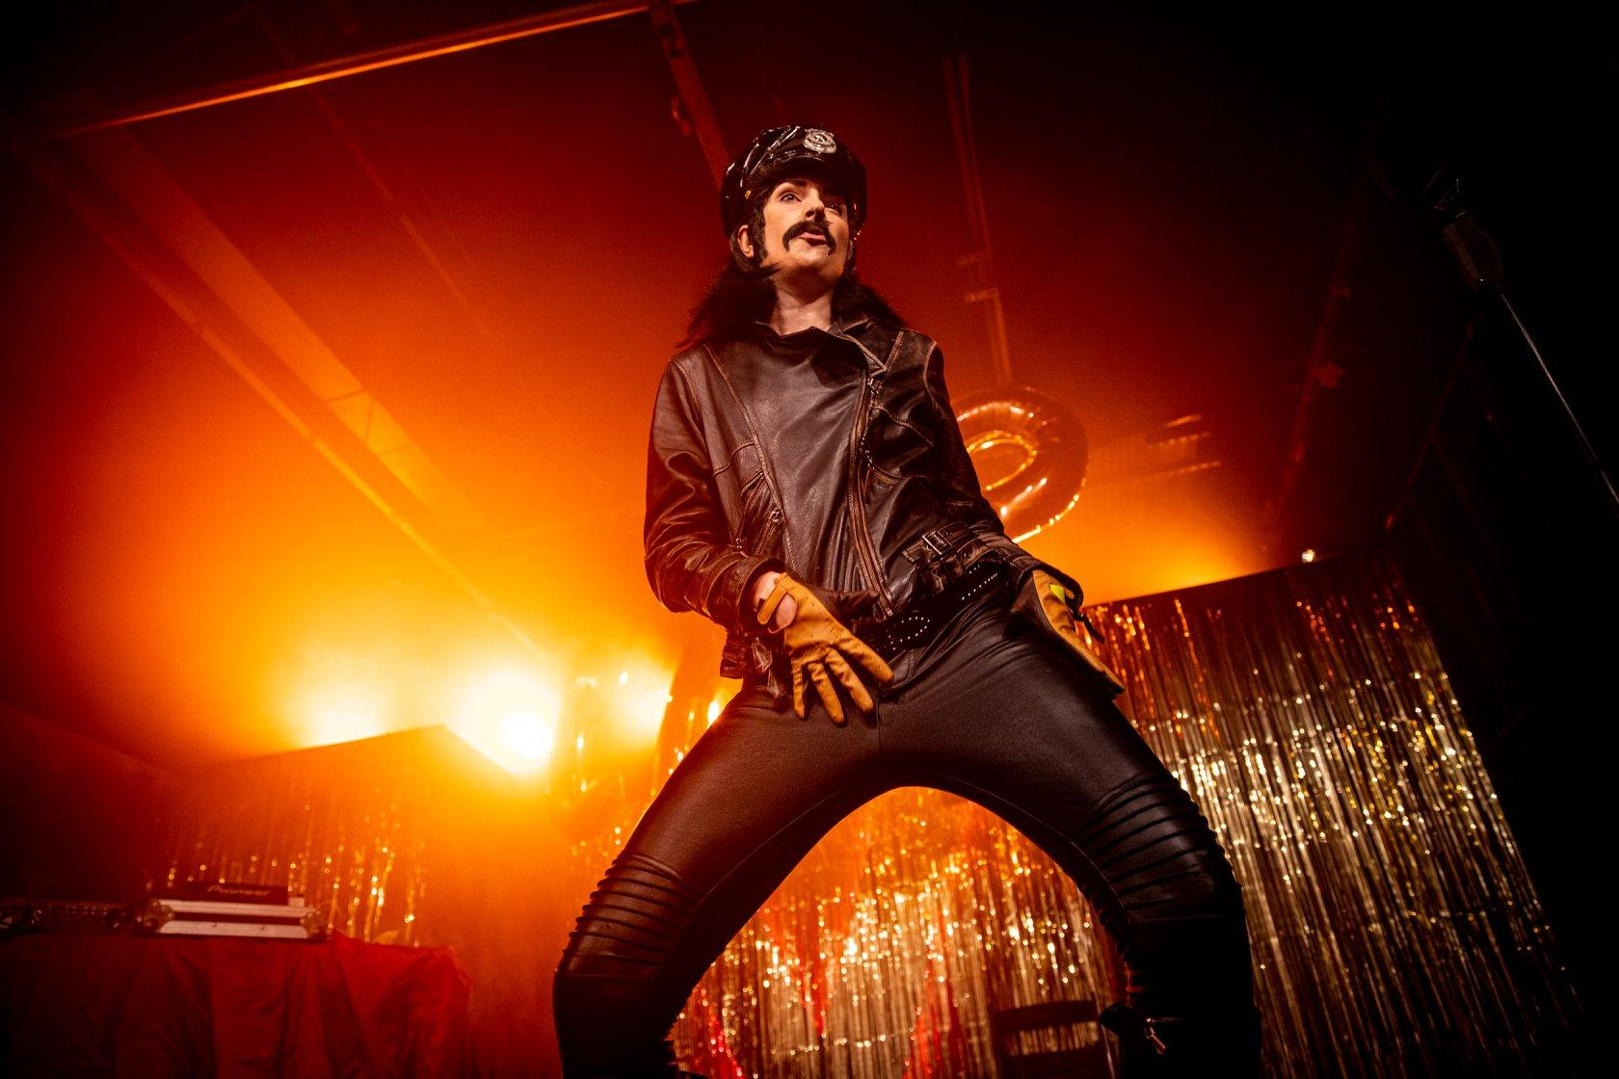

Image Description: King Loose Willis is standing in his leather daddy outfit, giving us a full manspread power stance, a hand gesturing to his crotch. The background is a gold slash curtain with bright orange and red lighting illuminating Loose from behind.

Image Credit: Harry Elletson

Highlights of our work include

SEX SEX, MEN MEN, 2019

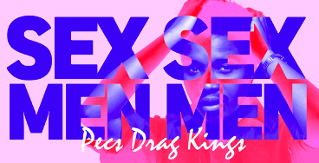

Image description: words SEX SEX MEN MEN are in bold blue text on top of a pink and red image of drag king cole who poses with his arms behind his head and smoulders through the text. The text Pecs Drag Kings is in calligraphy in white at the bottom of the image.

Critically acclaimed SEX SEX ,MEN MEN was developed with The Yard Theatre and Arts Council England. The show ran for 2 weeks before being extended for a third due to demand.

A formal departure from our usual style of cabaret, this piece pushed the boundaries of cabaret, performance art and theatre. 90 minutes of transgressive material challenged audiences’ expectations of queer desire & sexuality on stage.
​
Winner – IDEA Award – Offies 2020

“With consent at its heart and a strap-on at its hips, drag collective Pecs’ show is funny, smart and downright sexy.” ★★★★ The Guardian
“an intoxicating mix of masculinity and femininity, fucking with gender binaries and making space” Exeunt
“sex and masculinity in this queer, theatrical gem” DIVA Magazine

Pecs: The 80s Show, 2017

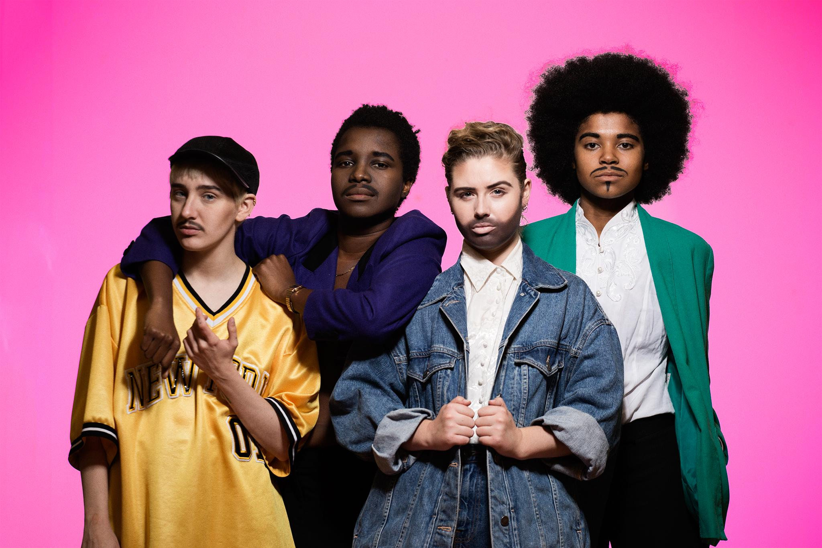

Image description: Victor Victorious, Drag King Cole, Thrustin Limbersnake and Izzy Aman stand together against a pink background, smouldering. They are wearing 80s inspired clothing, Victor in a yellow american football jersey, Drag King Cole in a purple suit, Thrustin in double blue denim, Izzy Aman in a green blazer and collarless white shirt. They look like they could be a 80s pop group.

Image credit: Stephen Allwright
Pecs: The 80s show was presented at The Glory in March 2017 before transferring to Soho Theatre in December 2017. Both shows were a sell out and the show received a Off West End award nomination in the TBC category
The 80s Show was created as a direct response to the political upheaval and the rise of the severe right-wing of 2016, drawing comparisons between the 1980s and today while also celebrating the incredible queer pop icons of the 80s we lost in that year.
“empowers us all to put up a fight and make a change.” ★★★★★ Spy in the Stalls
“A fantastic show, brilliantly performed“ ★★★★★ LondonTheatre1
“changes your perspective whether you understand every nuance and reference or not.” ★★★★★ Theatre Bubble
“Funny and Political” ★★★★ The Stage

Pecsmas, 2019

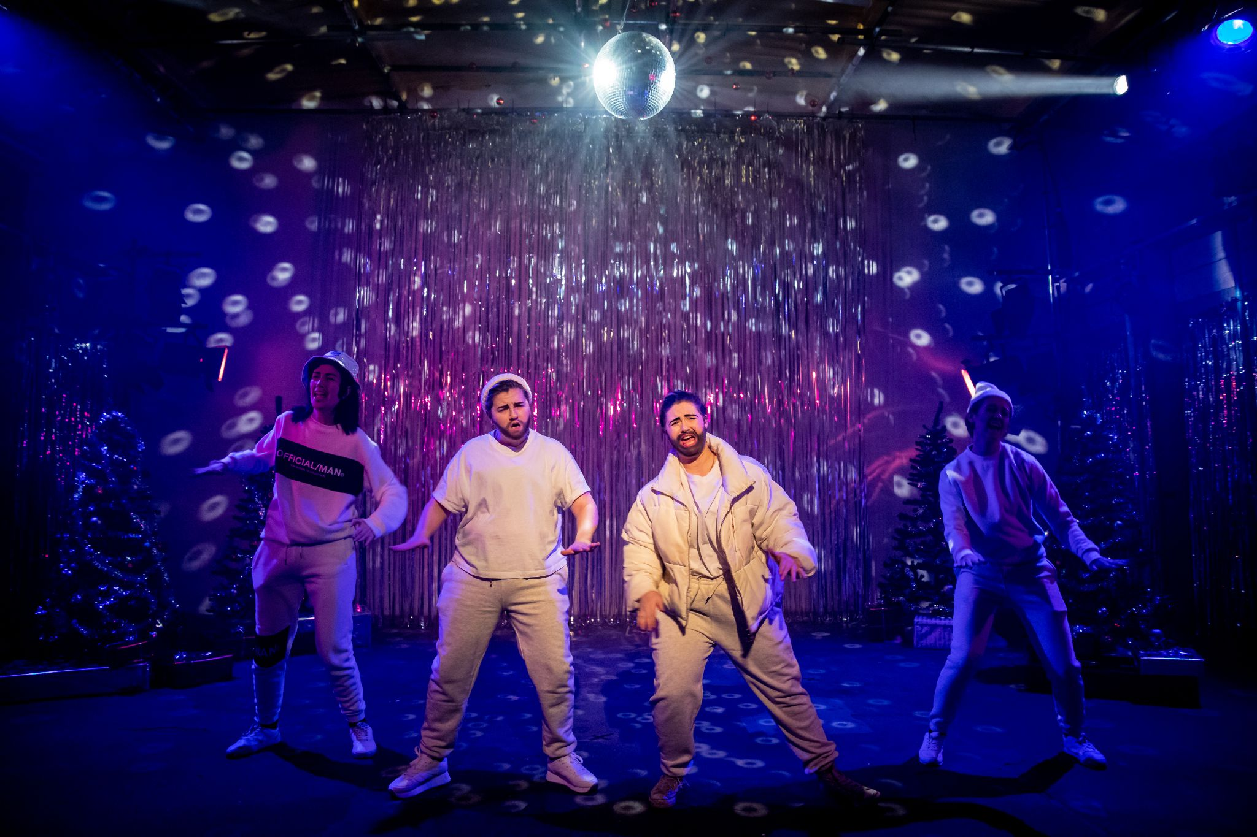

Image Description: 4 of the Pecs Kings stand side by side under a glitter ball, in full boy band poses, clothed in white tracksuits, like the members of East 17. They’re mid lip-sync, arms outstretched. Behind them is a silver slash curtain and 3 christmas trees. It’s full christmas camp glamour.

Image Credit: Harry Elletson

Pecs have been creating a Christmas show for the past 4 years. In 2019, we made ‘Pecsmas’, our slice of Christmas themed escapism for Queer chosen family which showcased the drag community through guest performances. The show ran for 2 weeks at The Yard to sold out audiences and great critical acclaim.

Pecsmas also raised over £1500 for the Outside Project through our collections on the door.

“Sparkly escapism wrapped in shiny red hotpants” ★★★★ The Guardian

“Pitch perfect performances meet searing social and political commentary in this most festive of Drag treats” DIVA Magazine

“A thoroughly unique christmas spectacular” ★★★★★ SPYINTHESTALLS

The Drag King Cast, 2020

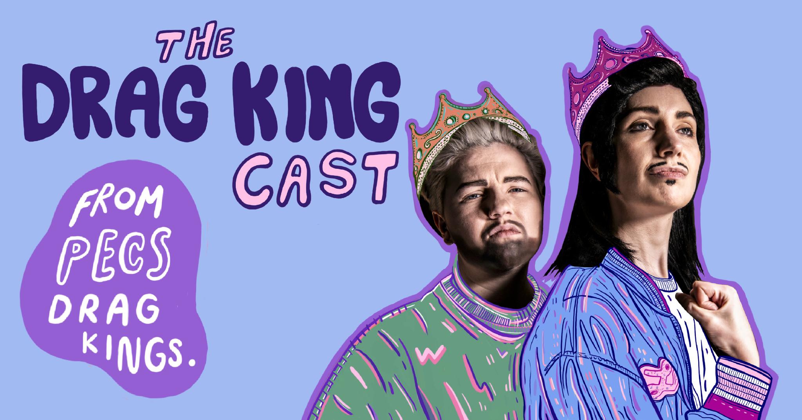

Image description: Kings John Travulva and Loose Willis are staring proudly into the distance. Their faces are a photograph, their bodies have been illustrated. John’s is green and pink, Loose Blue and pink. They both wear their crowns proudly. In big bubble writing is ‘The Drag King Cast from Pecs Drag Kings’.

Image Credit: Rah Petherbridge and Emma Hayden

In the wake of COVID-19, Pecs launched The Drag King Cast, the UK’s only podcast dedicated to platforming and amplifying Drag Kings. The first series has had over 1500 streams already, launched a Patreon and we are currently working on a second series.

In this 8 part podcast series, our hosts Jodie Mitchell (John Travulva) and Katy Bulmer (Loose Willis) interviewed some of our very favourite performers on what it means to perform as ‘male’ while navigating a largely cis male performance space.

Featuring guests from the LGBTQ+ Drag King community; CHIYO, Christian Adore, Oedipussi Rex, Sigi Moonlight, Don One Wesley Dykes, Trinidad & TooGayThough and Beau Jangles.

2021/22

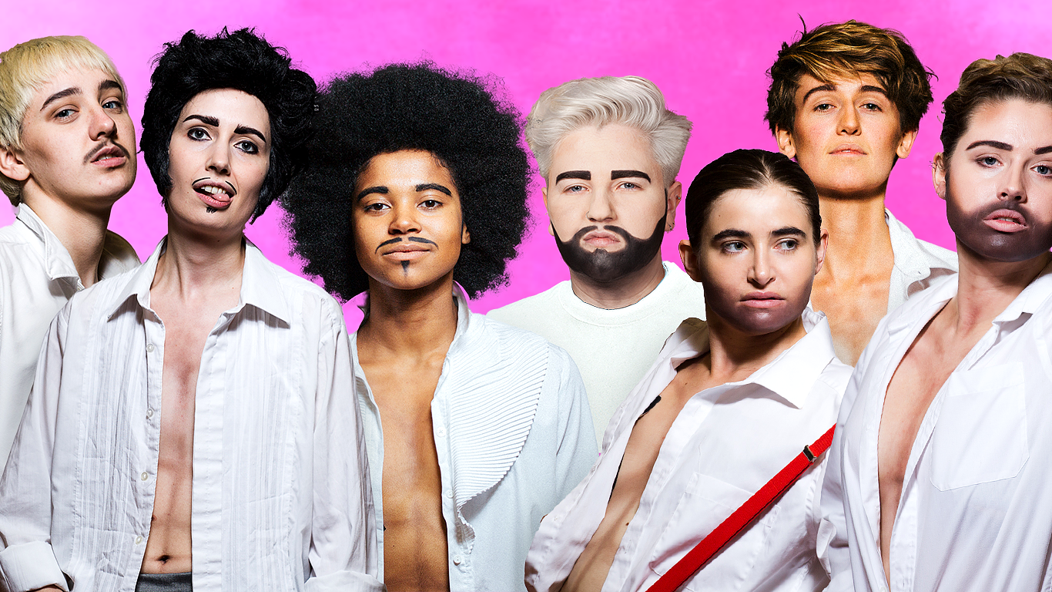

Image Description: Victor Victorius, Loose Willis, Izzy Aman, John Travulva, Mr Golden Balls, Scott Free and Thrustin Limbersnake all stand together in a composite image with a bright pink background, giving you their best sexy smoulders and powerful masculine poses. They wear white shirts, casually open so you can see their contoured chests.

Image Credit: Stephen Allwright

In September 2021 Pecs will make their return to Soho Theatre with ‘The Boys are Back in Town’, our love note to our audiences and community that we haven’t been able to perform for or gather with in person for so long.

At the beginning of 2021, Pecs were awarded a grant from Arts Council England to undertake strategic artistic work, research and development and launch a new workshop programme.

We will be starting a long-form R&D called ‘The Inspiration Project’, for us to bring new stimulus together and decide what Pecs would like to make in the future. Our new members would be invited to be part of this.

