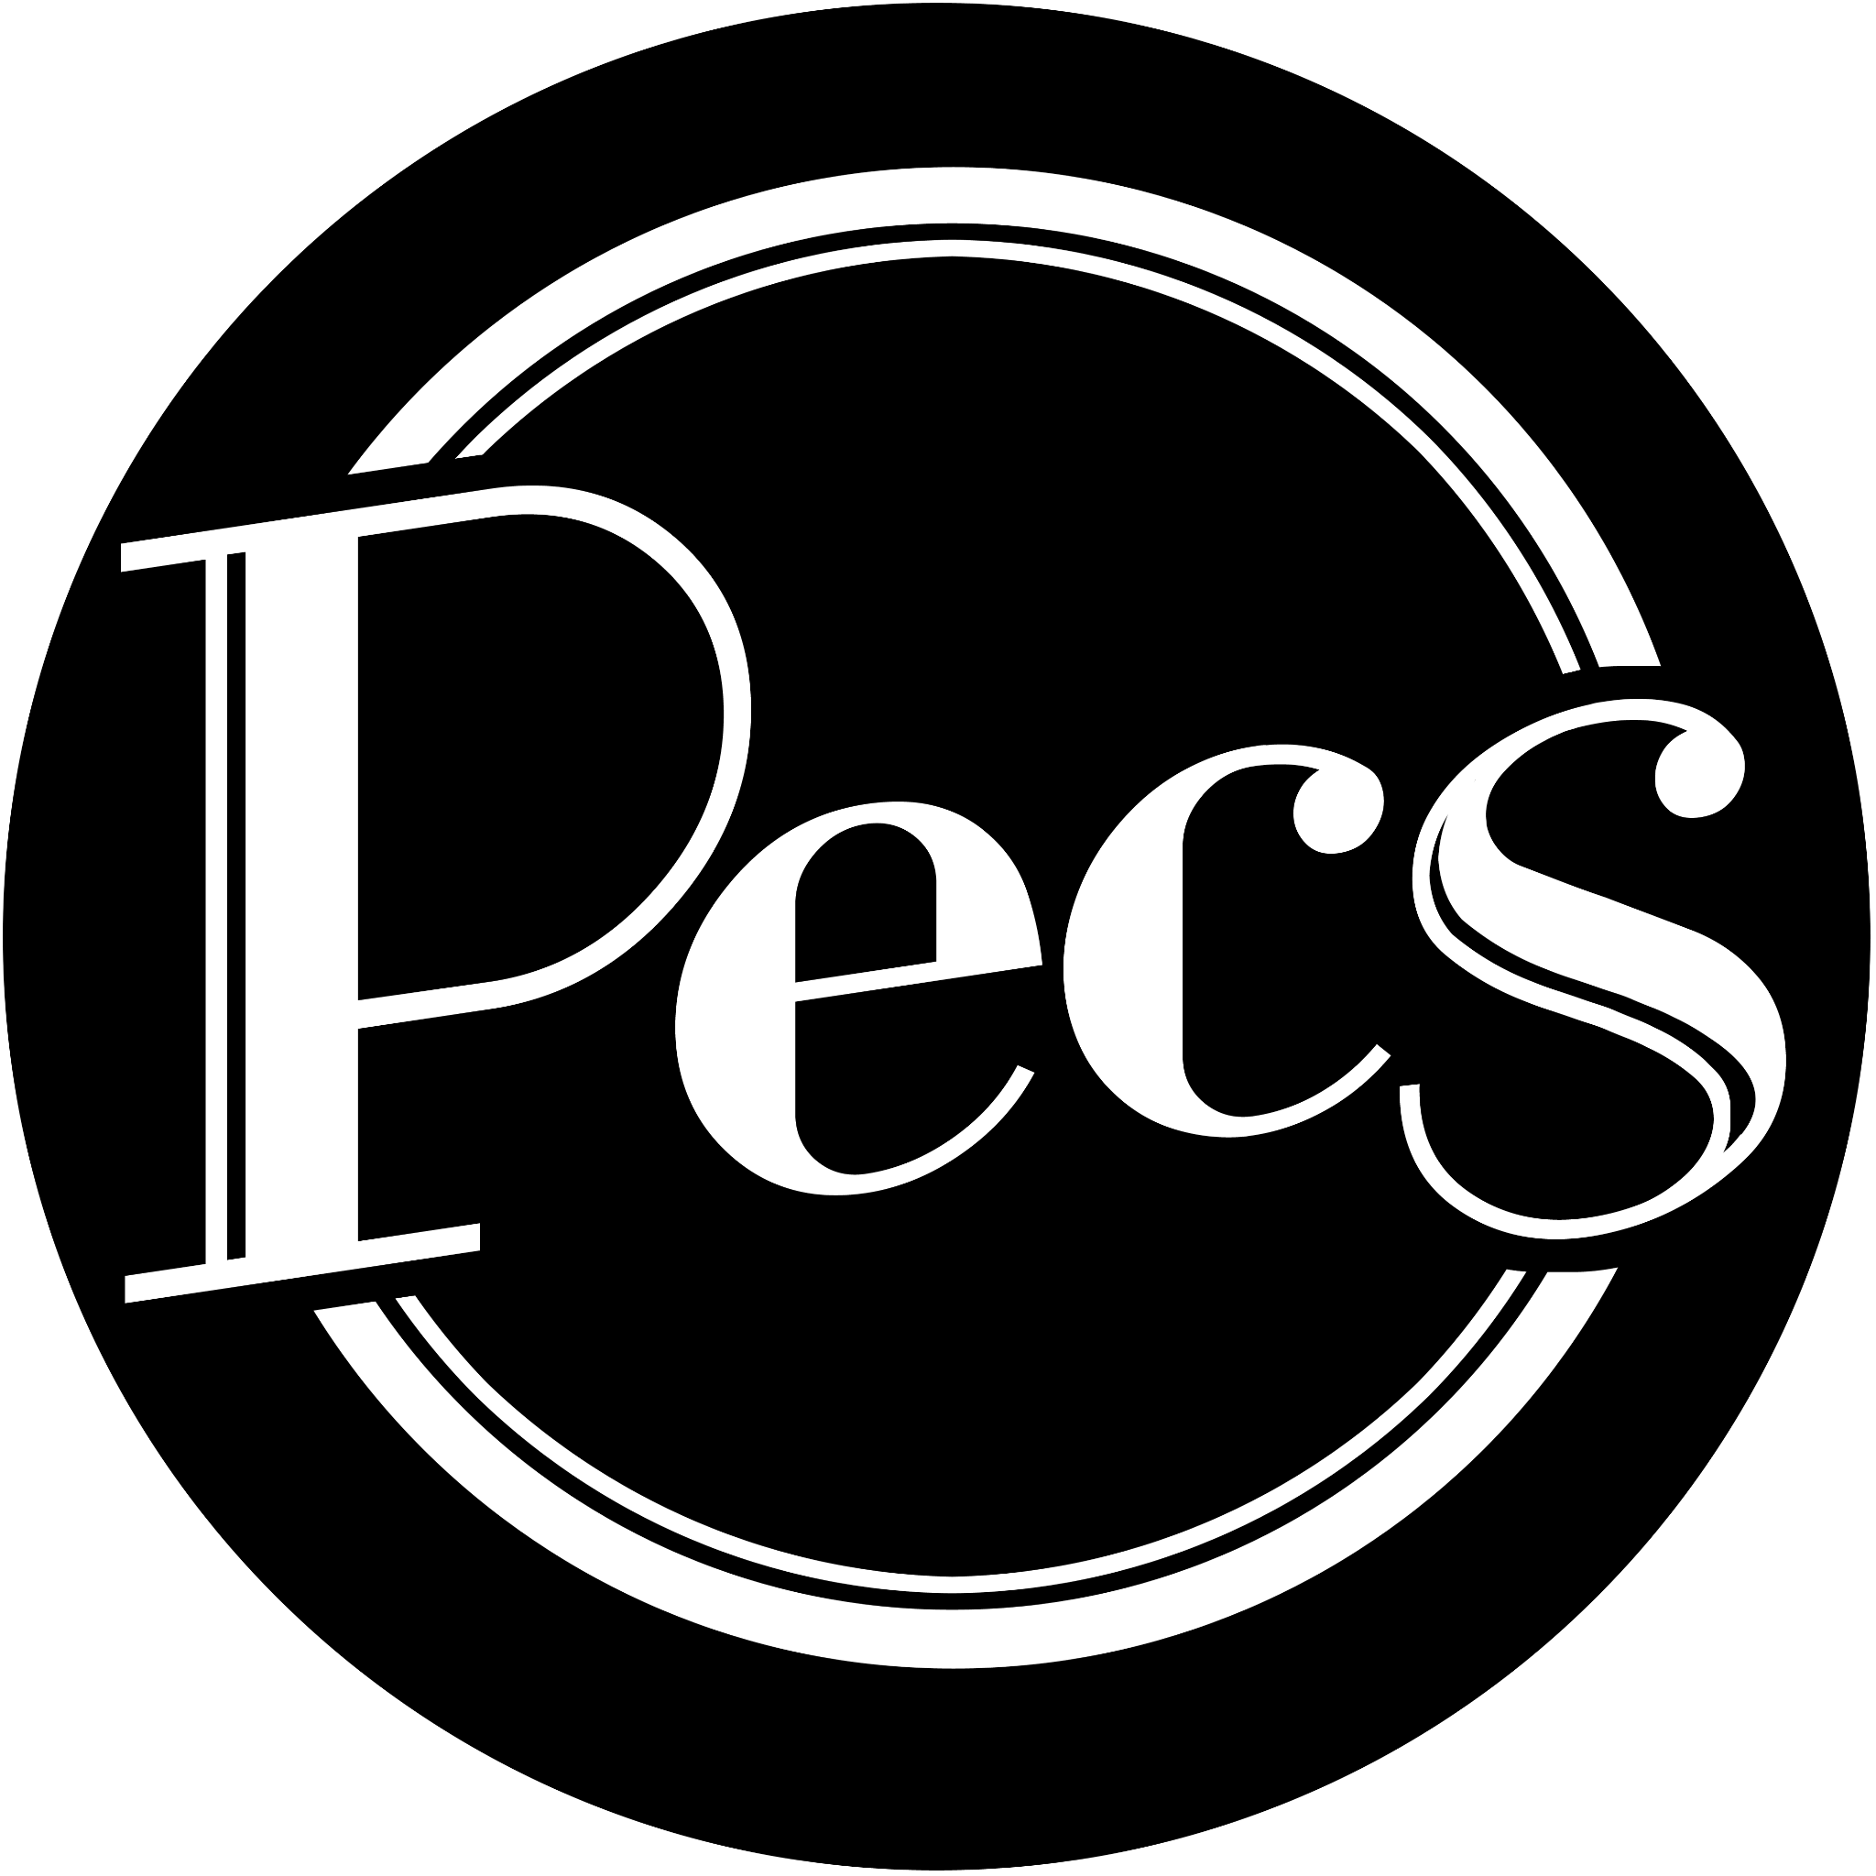

We are seeking 2 new members!

Over the past 2 years, we at Pecs have been doing some restructuring, training and building of our ambitions for the future. As our output and the scale of our work continues to grow, we are now at an exciting point in our development! We are inviting expressions of interest for 2 new members to join Pecs and be part of our work, company processes and decision making.

This is not a defined salaried role but rather an invitation to be part of Pecs as a collective, helping to guide how we work and our future output. Any performance or project work that our members undertake is always paid. Some of the work we do is not paid eg. general meetings, training, some admin tasks, but this is always optional depending on availability and energy.

We acknowledge that our company members do not represent the diverse racial backgrounds of the vibrant LGBTQIA+ Community. We are currently a majority white organisation and we acknowledge the bias this can have in our decision making. We have taken steps to ensure the organisation is a safe space for people from racially diverse backgrounds through undertaking Anti-Racism Training and continued personal learning. This call out for new members is the first organisational step to take positive action to recruit members from racially diverse backgrounds.

As such we are only seeking expressions of interest from those from the following backgrounds; African or Caribbean heritage
South Asian heritage
East Asian heritage
West Asian heritage
Central Asian heritage
South East Asian heritage
East Asian and South East Asian heritage
Middle East and North African heritage
and those who have experienced racism.

By the term ‘those who have experience racism’, we are referring to individuals who have experienced discrimination based on the colour of their skin, race and / or their culture.

How we work

The company operates on a horizontal structure. We don’t have a “hierarchy”, but rather all acknowledge that each person has a specific set of skills that they use in their role and as such has sign off on specific things. We all have certain responsibilities relating to our skill set and interests, but this structure enables anyone in the company who would like to to take a lead on a project with support from the others in place. We make all key decisions relating to the company (what shows to do, what direction to take, etc) as a group.

Currently, the roles of the members of Pecs are as follows:

Executive Producers: Daisy Hale & Ellen Spence
Creative Director: Celine Lowenthal
Creative Associates: Fiona Shaw, Helena Fallstrom, Jodie Mitchell, Lauren Steele, Vic Aubrey, Rosie Potts, Katy Bulmer, Isabel Adomakoh Young

Pecs Drag Kings is a Ltd company, limited by guarantee of £1. All members of Pecs are also invited to become co-directors of the company legally if they wish and the company is co-owned by its members.

Pecs work together in person when possible and over Basecamp, zoom, email and whatsapp. We meet monthly as a company for a general meeting, with other project based meetings & rehearsals scheduled around this.

(We also keep a separate ‘Lads Only’ whatsapp chat away from work dedicated to socials and fun times)

The Role

Our 2 new members of Pecs will become ‘Creative Associates’.

Creative Associates are primarily performers and creatives who make up the casts of our shows, club nights, cabarets & teach our drag workshops.

Creative associates are also welcome to:
- Run Projects! – Any creative associate can take the lead on a public or internal project that is approved by the company, they will receive support and guidance from the Exec Producers, Creative Director and other members where appropriate.
- Make Digital Work and do digital marketing! - To take part in the voluntary social media rota, promote Pecs online where possible, to produce digital content for Pecs.
- Be a Company Ambassador! – to consciously acknowledge Pecs in their Drag & performance work and seek out opportunities to pass back opportunities to the whole company.
- Communicate! – to actively take part in comms systems online and off, maintaining good comms for transparency & efficiency, to take part in secretarial duties (scheduling company meetings, taking notes) on rota.
- Fundraise! – to partake in fundraising efforts e.g. creating content for Patreon, writing to donors, assisting with funding applications.
- Be creative! - to contribute to creative projects, discussion and make work!
The amount of work any person in the company undertakes is subject to their own capacity, nobody is obligated to do more than they are able.

Who we are looking for

We are seeking out exciting performers to be part of Pecs. You don’t already need to be a seasoned Drag King, or even know who your drag persona is, that’s something we can find with you. But performance skills and an enthusiasm for Drag Kinging are a must.

Person Specification

- Excited by the Drag King community and recognises its value
- Someone of African or Caribbean heritage, South Asian heritage, East Asian heritage, West Asian heritage, Central Asian heritage, South East Asian heritage, East Asian and South East Asian heritage and people of Middle East and North African heritage* and those who have experienced racism. By the term ‘those who have experience racism’, we are referring to individuals who have experienced discrimination based on the colour of their skin, race and / or their culture.
- 18+
- A performer!
- Based in London.
- Happy to work within our online and in person systems.

We actively welcome applications from those who identify as D/deaf and/or disabled and those from low socio-economic backgrounds who intersect with the specification above.

Access

Pecs is committed to widening access to working in the arts and value the positive impact that difference has on our company.

All members of Pecs are currently Disability Equality Trained and have taken part in Anti-Racism Training. We operate a ‘learning club’ where we share reading / documentaries / podcasts and more on these specific topics to continue evolving our knowledge. Anti Racist actions and Disability Equality are cemented sections of our monthly meetings where we can continue to make progress and hold ourselves accountable.

Both new members will receive Disability Equality Training.

“I had the pleasure of delivering Anti-Racism Training to the Pecs Team. They were attentive, curious and very aware of their own privileges. Pecs undertook this training in order to ensure they are creating a safe environment for people from racially minoritised backgrounds. I was so impressed with their self-awareness and sensitivity. As a South Asian woman I would feel both comfortable and respected in my identity within the Pecs community.” - Jass Thethi, Intersectional GLAM

How To Apply

To express your interest in being part of Pecs, please fill out this FORM by Friday 9th July 2021 answering some short questions and uploading a video of yourself of no more than 5 minutes showing us your creativity /performance skills.

If you don’t have access to a video recording device, you are welcome to upload a piece of writing, voice note or other form of creativity.

If the google form is inaccessible to you, please contact Daisy, who is a trained access support worker, on pecsdrag@gmail.com and they will support you with your application. Please put ACCESS SUPPORT in the subject of your email.

If you have any questions surrounding the application or Pecs please contact Daisy & Ellen on pecsdrag@gmail.com

We ask all applicants to anonymously complete an Equal Opportunities Monitoring Form. This helps us to track how well we’re doing with attracting applications from a wide range of people.

Once the application deadline has passed, we will inform all applicants of our envisioned timeline for shortlisting, including a date you will hear back by. We will give every applicant an answer.

We will shortlist up to 10 applicants who we’ll invite to an informal chat to allow us to meet and for both parties to ask any questions. We will then invite 2 people to join Pecs.

Thank you for reading and we can’t wait to see your applications.

www.pecsdragkings.com

pecsdrag@gmail.com

https://www.facebook.com/Pecs.thedragkings

https://www.instagram.com/pecsdragkings/

https://twitter.com/pecsdrag

